

University of New Haven Tagliatela College of Enginneering Database Systems CSCI 6622

Section03 FINAL PROJECT

Title: Dentist Polyclinic Management System

Team: Avengers Part 2

Team Members:

Sumanth Reddy Desireddy Lalithya krishna garage Pavan Kalyan Duggempudi

Introduction

Dental Clinic is an organization that is responsible in providing a health

medication and treatment for all types of dental patients. Surely, everyday there are people that need to use the dental clinic services. But how can clinic provide a faster and efficient services if they are still using the traditional method on their daily operation? The traditional method means the customers need to fill in their detail in registration form manually and the information will only keep in files. After the registration, the files will be place in the rack and this will cause problems like taking a longer time to retrieve the information, make mistakes during writing or misplaced the files.

Nowadays, technology has changed many aspects of life and people’s daily life is becoming indivisible from the network due to the development of Internet. With dental clinic management system, the process gets much faster and more efficient than traditional way. Even t0hough the dental clinic had a system, but they still do not use the application. It is because there are facing several problems during process management.

# Problem Statement or the issues :

* + Dissatisfaction with waiting time in the clinic reveals an important problem that needs to be resolved, possibly through limiting the number of patients to reduce the waiting time.
  + When using the relation approach for modeling data, there are a variety of mistakes that can be made that result in database errors.

The problem of incomplete or inaccurate data entry to persist.

# Goal / Objective Statement:

* + To maintain an effective and efficient patient care delivery system.
  + Cost effective and easily manageable.
  + To reduce the work of documentation.
  + To get easy access to patient data with correct patient history.

To improve Efficiency by avoiding human errors.

# Projected Business Benefits:

* + Blogs, Talk shows on oral health and dentistry.
  + Optimize the time you spend with your patients and create an accessible way to run your clinic with solutions as paperless office management tools.
  + Referral management systems, and secure communication instruments.

Able to organize more data from patients.

# Methodology:

* + Analyze all the properties required for the database.
  + Design ER diagram using all the properties and constraints.
  + Design Schema diagram.
  + Design UML Diagram using ER diagram.

Collect data from Dental hospital to insert the data into database.

# Entity Relationship Diagram (ER)

An entity–relationship model describes interrelated things of interest in a specific domain of knowledge. A basic ER model is composed of entity types and specifies relationships that can exist between entities.

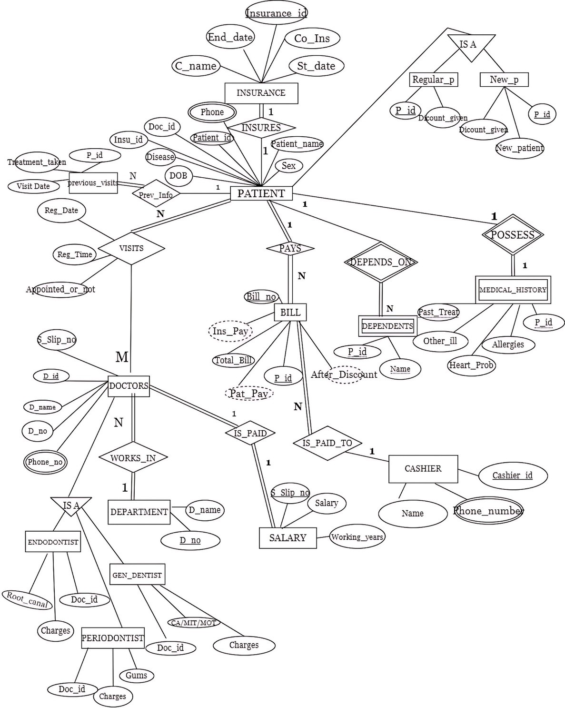

# Relational Schema Insurance

|  |  |  |  |  |
| --- | --- | --- | --- | --- |
| Insurance_id | Company_name | Start_date | End_date | Co_Insurnace |

**PRIMARY KEY**: Insurance_id

Patient1

|  |  |  |  |  |  |  |  |  |  |
| --- | --- | --- | --- | --- | --- | --- | --- | --- | --- |
| Patient  _id | Polyclinic_n ame | Patient_na me | do b | Insurance  _id | Se x | Disea se | Doc_ id | Registration_t ime | Registration_ date |

**PRIMARY KEY**: Patient_id

**UNIQUE**: Patient_name

**FOREIGN KEY**: Patient1(doc_id) references doctor_info(doc_id) Patient1(insurance_id) references insurance(insurance_id)

Patient Phone

Phone_number

Patient_id

**FOREIGN KEY** : Patient_phone(patient_id) references patient1(patient_id) VISITS

|  |  |  |  |  |
| --- | --- | --- | --- | --- |
| Patient_id | Patient_name | Registration_time | Registration_Date | Appointed_or_not |

**PRIMARY KEY**: PATIENT_ID

**FOREIGN KEY**: Visits (patient_name) references patient1(patient_name) Visits (patient_id) references patient1 (patient_id)

**PREVIOUS_VISITS**

|  |  |  |
| --- | --- | --- |
| Patient_id | Visits | prev_treatment_taken_from_this_clinic |

**FOREIGN KEY**: Previous_visits (patient_id) references patient1(patient_id)

**NEW PATIENT**

|  |  |  |  |  |
| --- | --- | --- | --- | --- |
| Patient_id | Patien_name | Insurance_id | New_patient | Discount_given |

**PRIMARY KEY**: Patient_id

**FOREIGN KEY:** new_patients (patient_id) references patient1(patient_id); New_patients (patient_name) references patient1(patient_name) New_patients (insurance_id) references patient1(insurance_id)

**REGULAR PATIENT**

|  |  |  |  |
| --- | --- | --- | --- |
| Patient_id | Patient_name | Insurance_id | Discount_given |

**PRIMARY KEY**: Patient_id

**FOREIGN KEY**: regular_patients (patient_id) references patient1(patient_id); regular_patients (patient_name) references patient1(patient_name) regular_patients (insurance_id) references patient1(insurance_id)

**DOCTOR_INFO**

|  |  |  |  |  |
| --- | --- | --- | --- | --- |
| Doc_id | Salary_slipno | Doc_name | Dep_no | Dep_name |

**PRIMARY KEY**: Doc_id

**UNIQUE**: Salary_slipno

**FOREIGN KEY**: Doctor_info (Dep_no) references department(Dep_no) Doctor_info references department(dep_name)

Doctor_info (salary_slipno) references doc_salary (salary_slipno)

**DOCTOR_PHONE**

Phone_number

Doc_id

**FOREIGN KEY**: DOCTOR_PHONE (doc_id) references doctor_info(doc_id)

**DOCTOR_SALARY**

|  |  |  |
| --- | --- | --- |
| Salary_slipno | Salary | Number_of_years_working |

**PRIMARY KEY:** Salary_slipno

**DEPARTMENT**

Dep_name

Dep_no

**PRIMARY KEY**: dep_no

**UNIQUE**: Dep_name

**ENDODONTIST**

|  |  |  |
| --- | --- | --- |
| Doc_id | Gums | Price |

**FOREIGN KEY:** periodontist (doc_id) references doctor_info(doc_id)

**GEN_DENTIST**

|  |  |  |
| --- | --- | --- |
| Doc_id | Cavities_or_missing_teeth_or_mobile_teeth | Price |

**FOREIGN KEY:** gen_dentist (doc_id) references doctor_info(doc_id)

**TOTAL_BILL**

|  |  |  |  |  |  |  |
| --- | --- | --- | --- | --- | --- | --- |
| Bill_no | Patient_id | Total_charge | After_discount | Money_insurance | Patient_pay | Cashier_id |

**PRIMARY KEY:** bill_no,patient_id

**FOREIGN KEY:** TOTAL_BILL (cashier_id) references cashier(cashier_id) TOTAL_BILL (Insurance_id) references patient1(insurance_id) TOTAL_BILL (patient_id) references patient1(patient_id)

TOTAL_BILL (patient_name) references patient1(patient_name)

**DEPENDENTS**

|  |  |  |
| --- | --- | --- |
| Dependent_name | Patient_id | Phone_number |

**PRIMARY KEY**: Dependent_name,patient_id

**FOREIGN KEY**: Dependents(patient_id) references patient1(patient_id)

**MEDIC_HISTORY**

|  |  |  |  |  |  |
| --- | --- | --- | --- | --- | --- |
| Patient_id | Past_treatment | Allergies | Pain_tooth | Heart_probs | Other_illness |

**PRIMARY KEY**: Patient_id,past_treatment

**FOREIGN KEY**: Medic_history (patient_id) references patient1(patient_id)

**CASHIER**

|  |  |  |  |
| --- | --- | --- | --- |
| Cashier_id | Name | Phone_number | Salary |

**PRIMARY KEY:** Cashier_id

**CASHIER_PHONE**

Phone_number

Cashiers_id

**Foreign key**: Cashier_phone(cashier_id) references cashier(cashier_id)